**SemanticBI: quantifying intensities of transcription factor-DNA binding by learning from an ensemble of experiments**

**Supplementary Information 1**. The hyperparameter configuration and model structure of SemanticBI. (A) Table S1 is the hyperparameter configuration of SemanticBI used on both PBM_66 data. (B) Figure S1 is the model structure of SemanticBI for PBM_66 data.

|  |  |
| --- | --- |
| **Supplementary Information 1 -** Table S1 | |
| ﻿Type of hyperparameter | Value of hyperparameter |
| CNN, LSTM, dense kernel initializer | Glorot_uniform |
| CNN, first dense, second dense activation | ReLU |
| CNN filters | 80 |
| CNN kernel size | 9 |
| CNN padding | Same padding |
| BatchNormalization momentum | 0.99 |
| LSTM units | 200 |
| LSTM recurrent activation | Hard sigmoid |
| LSTM recurrent initializer | Orthogonal |
| BLSTM merge mode | Sum |
| First dense units | 400 |
| Second dense units | 220 |
| Dropout rate | 0.25 |
| Third dense units | 1 |
| Third dense activation | Sigmoid |
| Loss function | Mean Squared Error / Binary Crossentropy |
| Optimizer | Adaptive Moment Estimation(Adam) |
| Adam learning rate | 0.001 |
| Adam beta_1 | 0.9 |
| Adam beta_2 | 0.999 |
| Adam decay | 0 |
| Batch size | 1000 |
| Epochs | 100 epochs |
| Rate of validation | 0.1 |
| Checkpoint monitor | Validation loss |
| ReduceLR monitor | Train loss |
| ReduceLR factor | 0.1 |
| ReduceLR patience | 6 epochs |
| ReduceLR minimum learning rate | 0.00001 |
| EarlyStop patience | 10 epochs |
| EarlyStop monitor | Validation loss |
| Power_rate in binding affinity of train set | 0.3 |

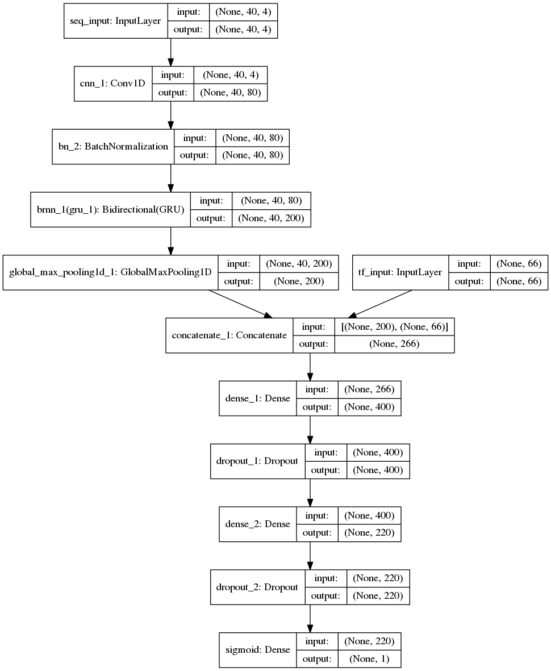

**Supplementary Information 1** - Figure S1

**Supplementary Information 2.** The distribution of binding intensities for each PBM datasets. (A) Figure S2 is the sorted distribution of binding intensities for each training set of PBM datasets. (B) Figure S3 is the sorted distribution of binding intensities for each testing set of PBM datasets. (C) Figure S4 is the sorted distribution of binding intensities for each normalized training set of PBM datasets. Most of intensities for some TFs locate to a small region in the left side of axis. (D) Figure S5 is the sorted distribution of binding intensities for each normalized and powered training set of PBM datasets.

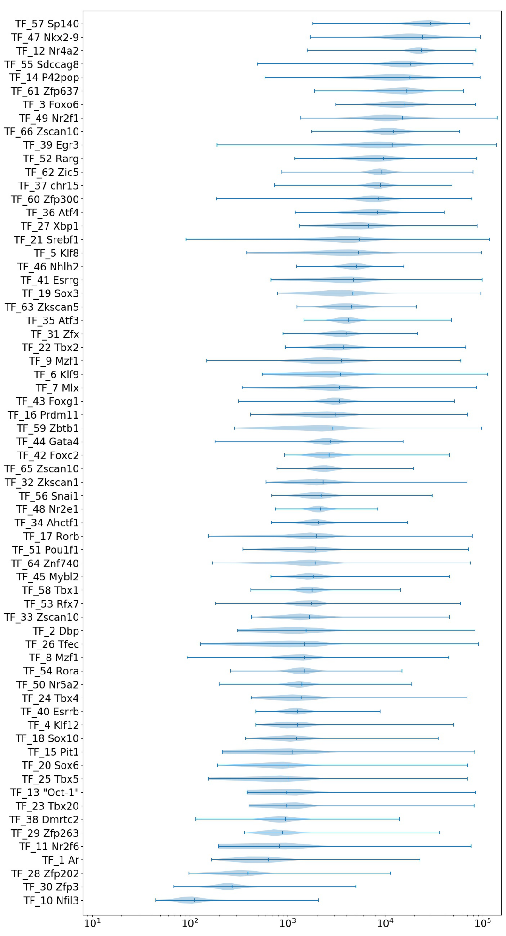

**Supplementary Information 2** - Figure S2

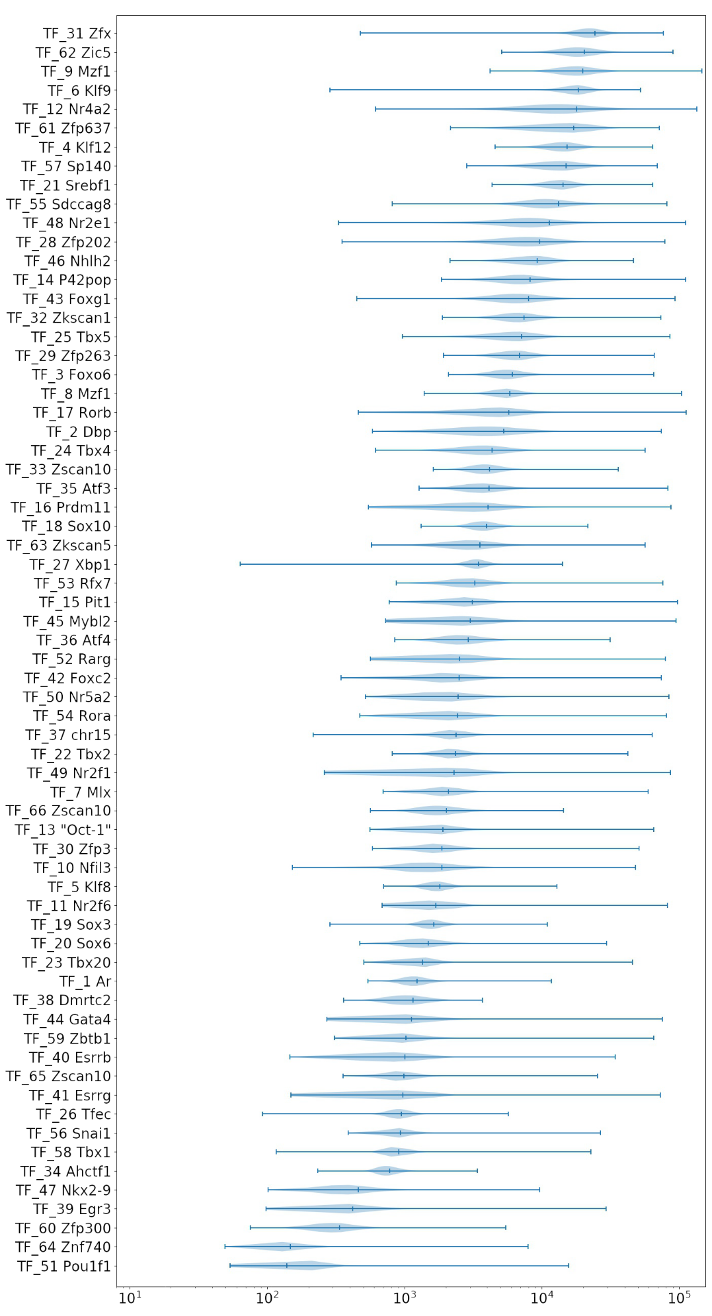

**Supplementary Information 2** - Figure S3

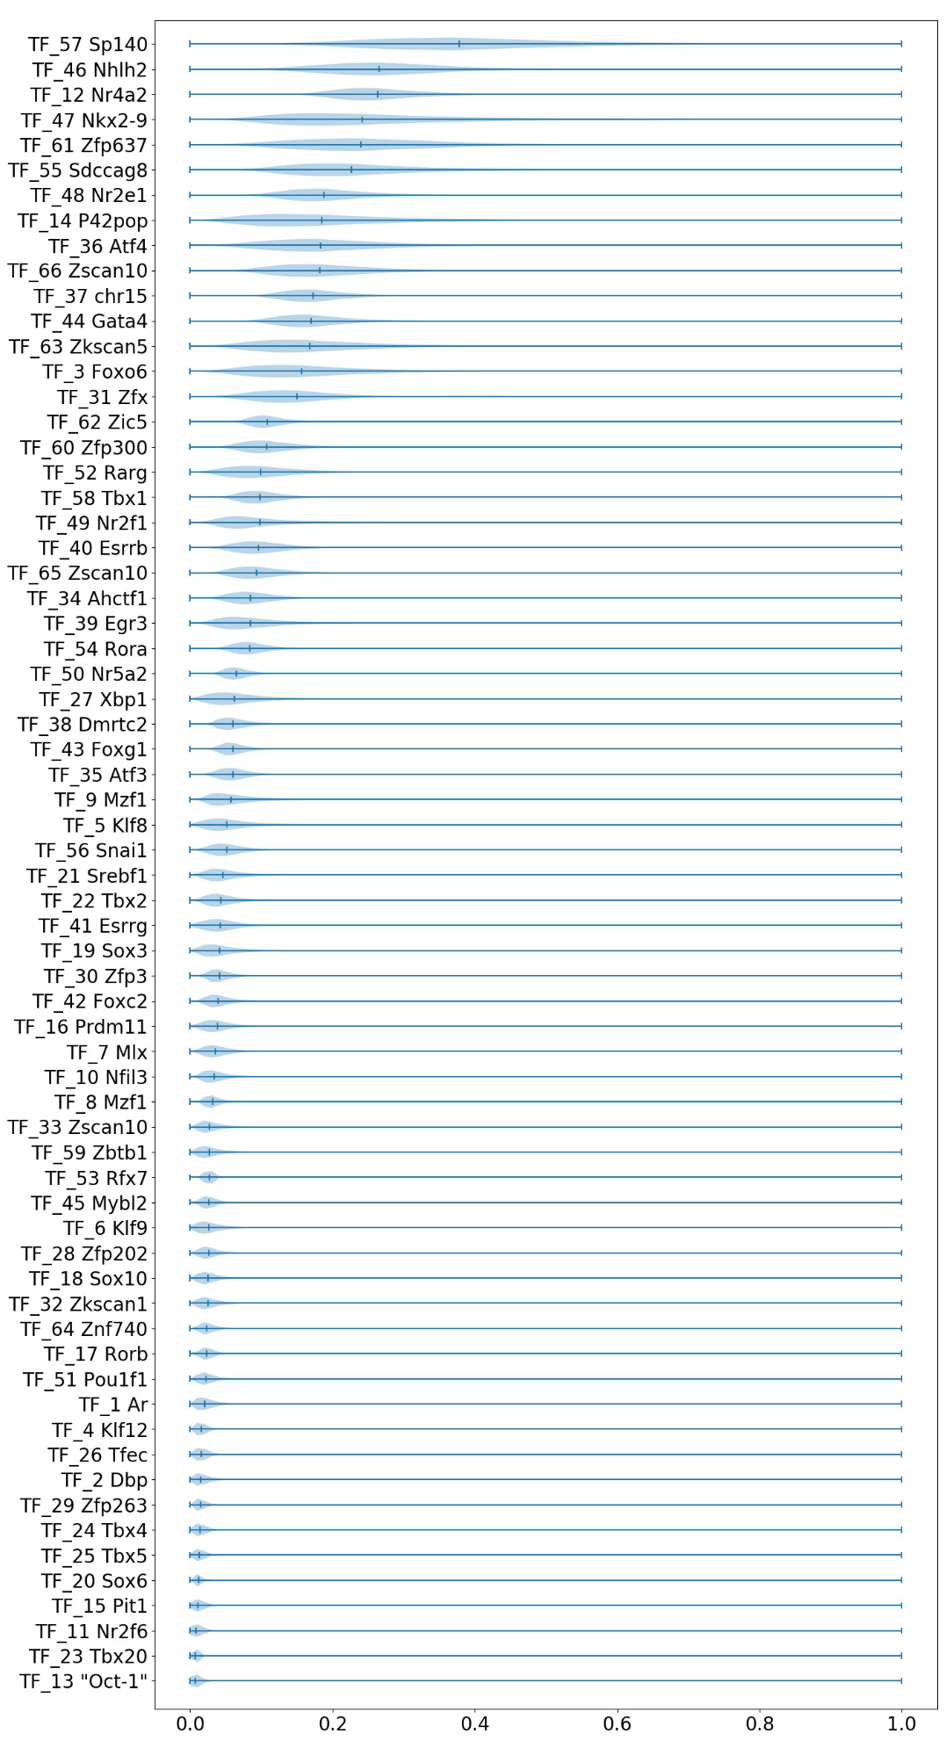

**Supplementary Information 2** - Figure S4

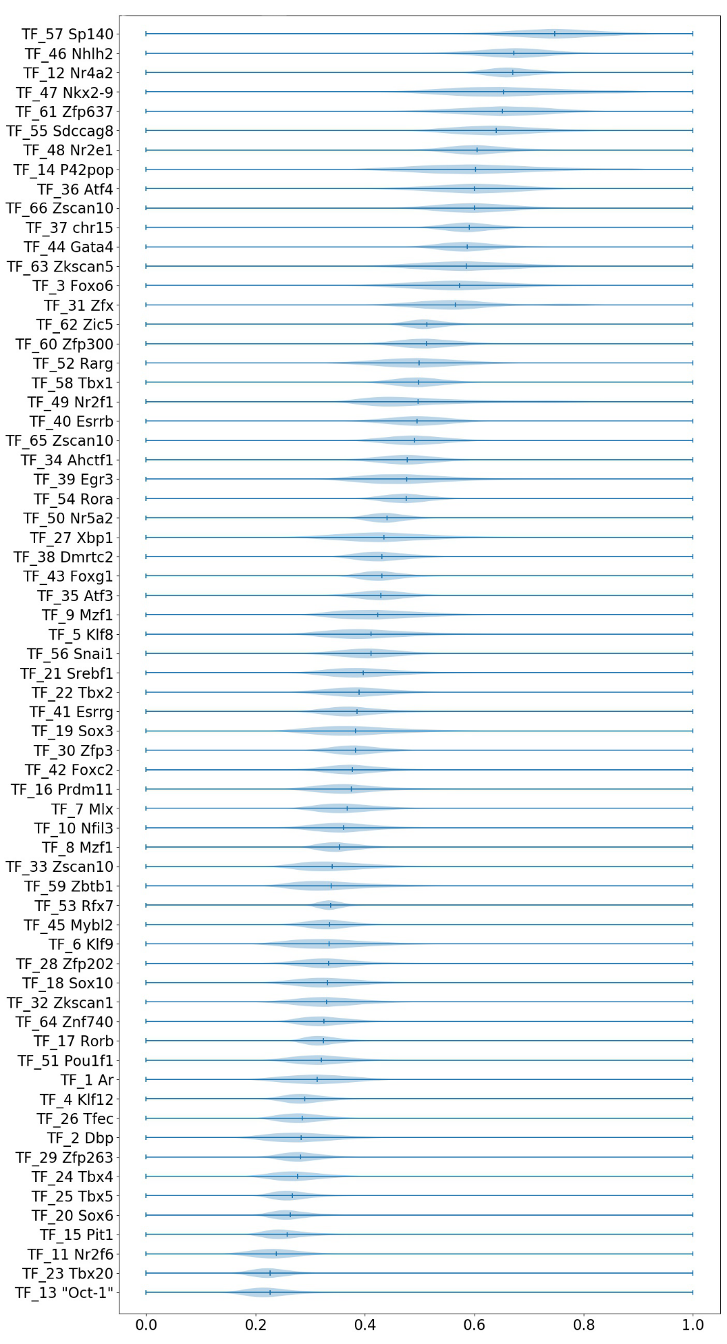

**Supplementary Information 2** - Figure S5

**Supplementary Information 3.** The details of sequence-oriented feature experiments. (A) SemanticFeatureBI and SemanticFeatureSNV are two abstract model, whose protocol is shown in Figure S6. First, feed one hot encoding sequence to the fine-trained SemanticBI model, and obtain the sequence-oriented features by SemanticBI's CNN-RNN architecture. Second, fit targets using a shallow machine learning model with sequence-oriented features as the representation of sequences. (B) SemanticFeatureBI was also trained on PBM datasets provided by PBM_NBT06 (Berger et al. (2006)) and PBM_Cell08 (Berger et al. (2008)). The input of SemanticFeature is sequence-oriented features generated by PBM_66 SemanticBI. And the shallow machine learning of SemanticFeature is Support Vector Regression with epsilon = 0.1 and C = 5. (C) Details of the experiment from CADD framework: The representation of sequence is from PBM_66 SemanticBI. The input of paired sequence is the combination of positive sequence’s sequence-oriented feature and the element-wise subtraction of positive sequence’s sequence-oriented feature and negative sequence’ sequence-oriented feature. The shallow machine learning here was a two-layer fully connected layer, first layer had 400 units and second layer had 200 units.

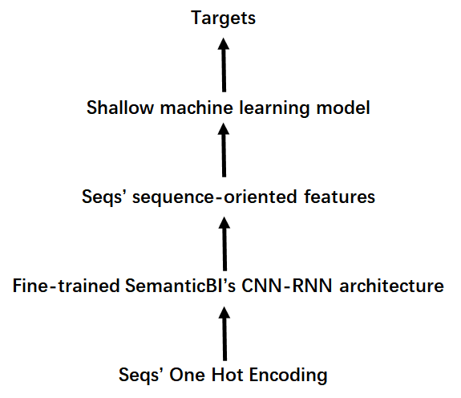

**Supplementary Information 3** - Figure S6

**Supplementary Information 4.** The details of Sharpr-MPRA experiment. The hyper-parameter configuration is in Table S1. Figure S7 is the model structure of SemanticBI for Sharpr-MPRA data. The data set used here is provided by the MPRA-DragoNN, and only four “_avg” groups were used by SemanticBI. Since we used the targets in the data set directly without any normalization, the last unit is a linear unit in SemanitcBI for Sharpr-MPRA experiment. The 4-length one hot inputs were K562, HepG2, SV40P and minP, respectively.

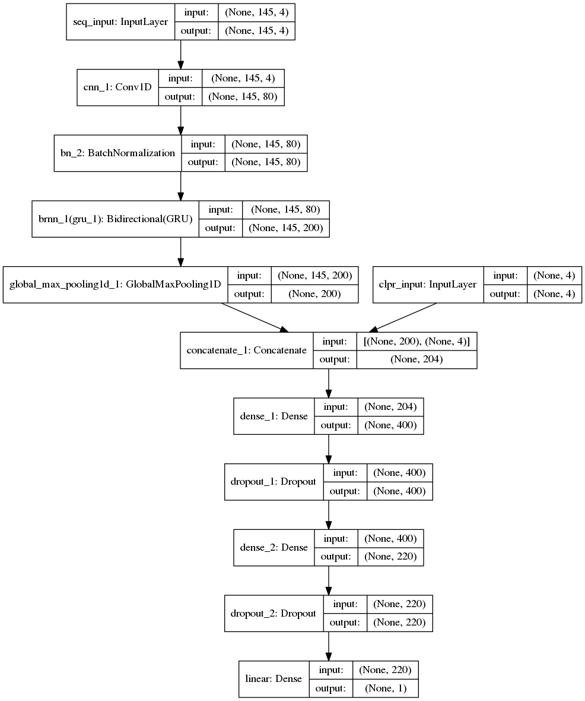

**Supplementary Information 4** - Figure S7

**Supplementary Information 5.** The details of PBM_20 experiment. (A) Figure S8 is the model structure of PBM_20 SemanticBI. The hyperparameter configuration of PBM_20 SemanticBI is shown in Table S1. (B) Table S2 contains the 20 TFs that were selected to train SemanticBI. More details on how we reduced PBM_66 to PBM_20 are shown in Supplementary Information PBM_20.

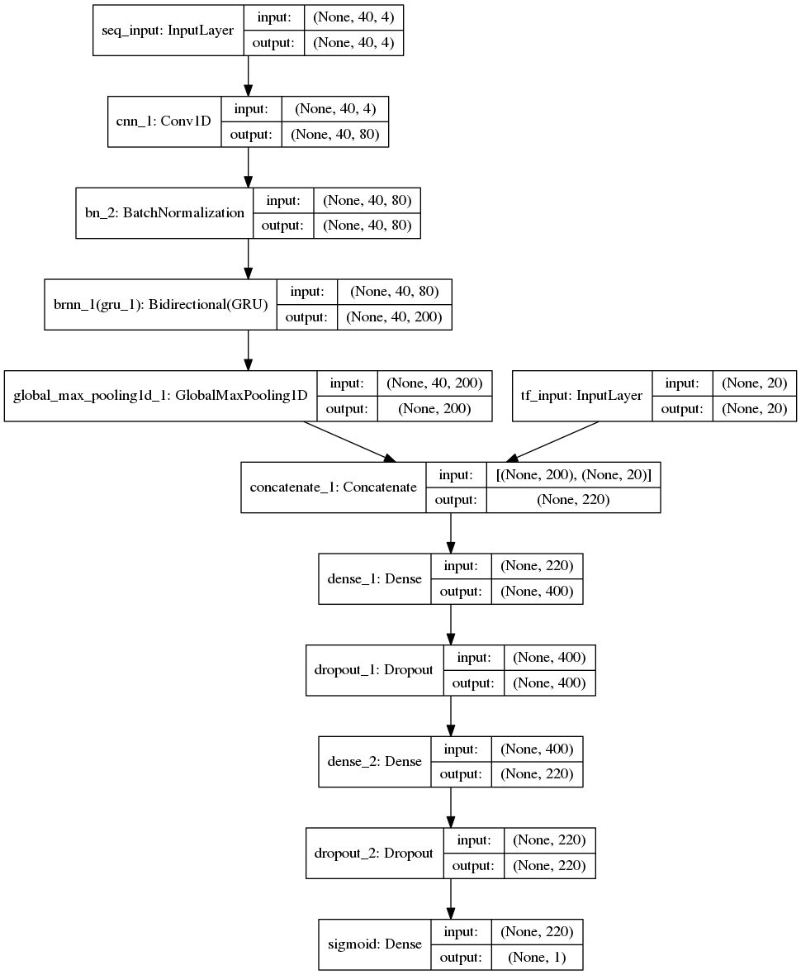

**Supplementary Information 5** - Figure S8

|  |  |  |
| --- | --- | --- |
| **Supplementary Information 5 -** Table S2: TF list of PBM_20 | | |
| **TF index** | **TF name** | **TF family** |
| TF_3 | Foxo6 | Forkhead |
| TF_4 | Klf12 | C2H2 ZF |
| TF_6 | Klf9 | C2H2 ZF |
| TF_8 | Mzf1 | C2H2 ZF |
| TF_12 | Nr4a2 | Nuclear receptor |
| TF_16 | Prdm11 | Myb/SANT |
| TF_20 | Sox6 | Sox |
| TF_22 | Tbx2 | T-box |
| TF_26 | Tfec | bHLH |
| TF_28 | Zfp202 | C2H2 ZF |
| TF_29 | Zfp263 | C2H2 ZF |
| TF_31 | Zfx | C2H2 ZF |
| TF_36 | Atf4 | bZIP |
| TF_38 | Dmrtc2 | DM |
| TF_39 | Egr3 | C2H2 ZF |
| TF_44 | Gata4 | GATA |
| TF_47 | Nkx2-9 | Homeodomain |
| TF_51 | Pou1f1 | Pou+Homeodomain |
| TF_53 | Rfx7 | RFX |
| TF_56 | Snai1 | C2H2 ZF |